Pimoroni Unicorn Hat - 8x8 RGB LED Shield for Raspberry Pi A+/B+

Adafruit PRODUCT ID: 2288

<https://www.adafruit.com/product/2288>

<https://shop.pimoroni.com/products/unicorn-hat>

3-pin header (as viewed below) left-to right: GND-DIN-VCC (Same order as when it is rotated and flipped to view from PCB layout front)

Spacing of the LED array 6.4mm??? NO

UPDATED WIDTH (across solder pads) MEASURED 1.853/7=.265 in. or 47.17 mm/7= 6.74 mm

UPDATED HEIGHT MEASURED 1.812/7=.259in. or 46.03/7=6.58mm

UPDATED Split the difference to use grid with .262 inches or 6.65 mm

Use Half steps .130 inches

UPDATED Corners of grid center at x/y 7 * .130 = 0.910

Mounting Holes: L-R 1-15/16” U-D 2-9/32”, hole dia .125”

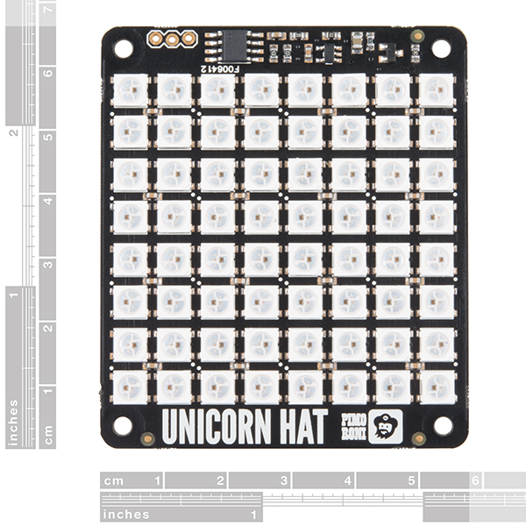holes at corners X=31/32 (.96875) Y= 1-9/64 (1.140625)



**0,0 is in the lower right of the above image.**

<http://fastled.io/> and <https://github.com/FastLED/FastLED/wiki/Basic-usage>

TECHNICAL DETAILS

* 65mm x 56mm x 6.5mm / 2.6" x 2.2" x 0.26"
* Weight: 20g



# DESCRIPTION

Snap the [Pimoroni](http://shop.pimoroni.com/)**Unicorn Hat** on top of a Raspberry Pi [model A+](https://www.adafruit.com/products/2266) or a [model B+](https://www.adafruit.com/products/1914) for a fun 8x8 RGB LED matrix powered directly from the Pi.

Unicorn HAT provides a wash of controllable color that is ideal for mood-lighting, 8x8 pixel art, persistence of vision effects, status indications, or just blasting colour into your surroundings.

* 64 RGB LEDs (**WS2812B**) each wtih 24-bit RGB color
* Python API (NeoPixel compatible!)
* EEPROM with Raspberry Pi HAT configuration details
* LED data driven via DMA over PWM Pin #18

Experimenting to figure out:

Color order: GRB

SerpentineLayout: true

# Unicorn HAT

What's going to protect your beloved Raspberry Pi from an onslaught of rainbow-coloured fusion? That's right, it's Unicorn HAT.

Sporting a matrix of 64 (8 x 8) RGB LEDs and powered directly from the Pi, this is the most compact pocket aurora available.

Unicorn HAT provides a wash of controllable colour that is ideal for mood-lighting, 8x8 pixel art, persistence of vision effects, status indications, or just blasting colour into your surroundings.

[The MagPi](https://www.raspberrypi.org/magpi-issues/MagPi42.pdf) said that Unicorn HAT was "one of the coolest HATs around"

## **Features**

* 64 RGB LEDs (WS2812B)
* LED data driven via DMA over PWM
* [Unicorn HAT pinout](https://pinout.xyz/pinout/unicorn_hat)
* Compatible with all 40-pin header Raspberry Pi models
* [Python library](https://github.com/pimoroni/unicorn-hat)
* Comes fully assembled

## **Software**

We've put together a [Unicorn HAT Python library](https://github.com/pimoroni/unicorn-hat) to make it a breeze to use, including lots of beautiful examples of what it can do.

## **Notes**

* **Warning**: WS2812 LEDs are bright enough to cause eye pain, do not look at them directly when brightly lit. We recommend the use of a [diffuser](https://shop.pimoroni.com/products/pibow-modification-layers).
* **Photo-sensitivity warning**: flashing, strobing, and patterns of lights may cause epileptic seizures. Always take care and immediately stop using if you feel unwell (dizziness, nausea, affected vision, eye twitching, disorientation).
* **Power**: Unicorn HAT requires a >2A microUSB power supply for your Pi. We recommend [the official Raspberry Pi power supply](http://shop.pimoroni.com/products/raspberry-pi-universal-power-supply).
* **Compatibility (audio)**: as Unicorn HAT uses PWM and GPIO18, it will interfere with analogue audio playback (random colour patterns and flickering). HDMI should work just fine! :D